***NAME : Himanshu Dixit***

***ENROLL NO. : B64178***

***BATCH : B10***

***SOFTWARE DEVELOPMENT FUNDAMENTAL LAB-I(15B17CI171) Assignment Sheet (WEEK-6 PHASE-2)***

***Lab B***

***1.*** *Write a C Program to remove all Characters in a String except Alphabets.*

***Solution:***

#include<stdio.h>

#include<string.h>

int main()

{

char a[100];

gets(a);

for(int i=0;a[i]!='\0';i++)

{

if(isalpha(a[i]))

printf("%c",a[i]);

}

return 0;

}

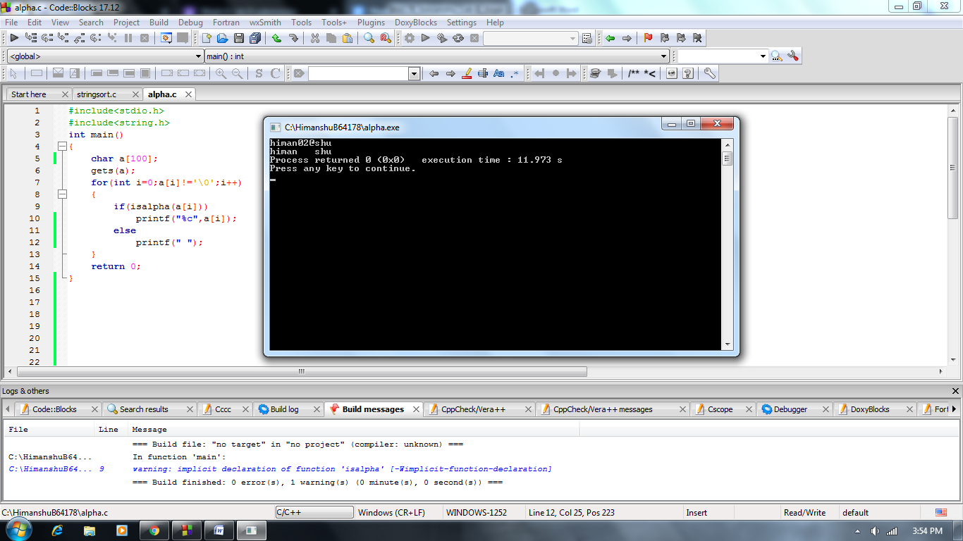

***2.*** *C program to find the length of a string without using the built-in function.*

***Solution:***

#include<stdio.h>

void main()

{

char a[100],count=0;

gets(a);

for(int i=0;a[i]!='\0';i++)

count++;

printf("%d",count);

}

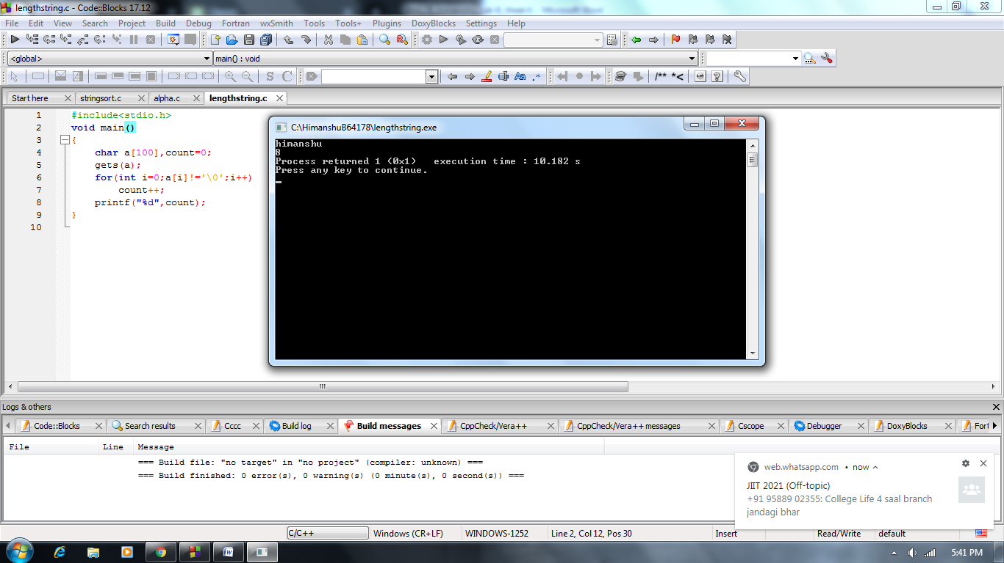

***3.*** *Write a C Program to Find the Frequency of Characters in a String.*

***Solution:***

#include<stdio.h>

void main()

{

char a[100];

int count=0;

gets(a);

int max=a[0];

for(int i=0;a[i]!='\0';i++)

if(max<a[i])

max=a[i];

for(char i=0;i<=max;i++)

{

count=0;

for(int j=0;a[j]!='\0';j++)

{

if(i==a[j])

count++;

}

if(count!=0)

printf("%c = %d\n",i,count);

}

}

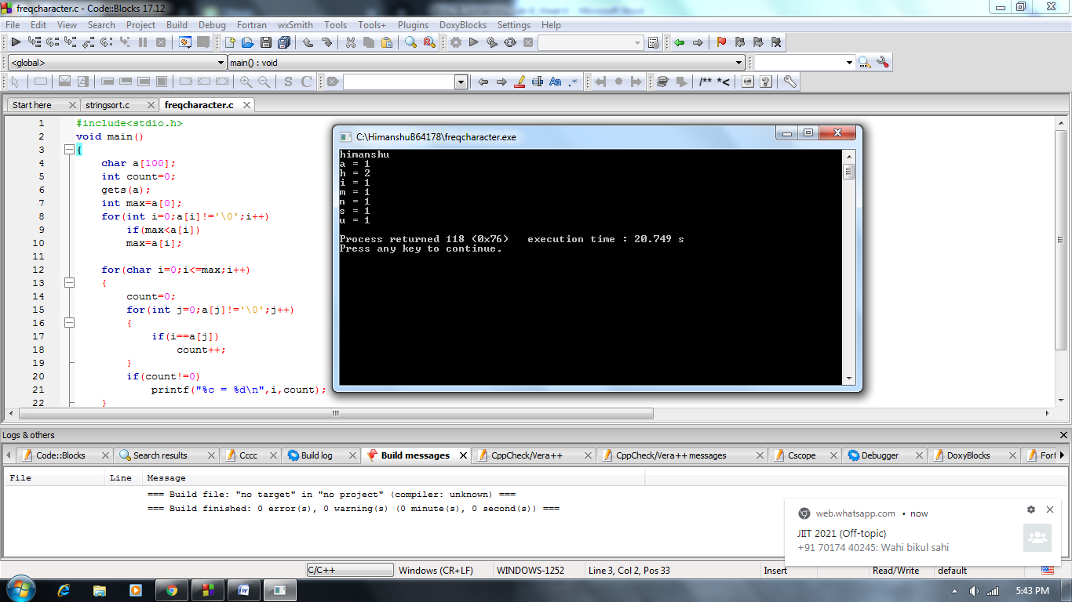

***4.*** *Write a C program to count total number of vowels and consonants in a string.*

***Solution:***

#include<stdio.h>

#include<string.h>

void main()

{

char a[100],cv=0,cc=0;

gets(a);

for(int i=0; a[i]!='\0'; i++)

{

if(a[i]=='a'||a[i]=='e'||a[i]=='i'||a[i]=='o'||a[i]=='u'||a[i]=='A'||a[i]=='E'||a[i]=='I'||a[i]=='O'||a[i]=='U')

cv++;

else if(isalpha(a[i]))

cc++;

}

printf("total vowel = %d",cv);

printf("\ntotal consonant = %d",cc);

}

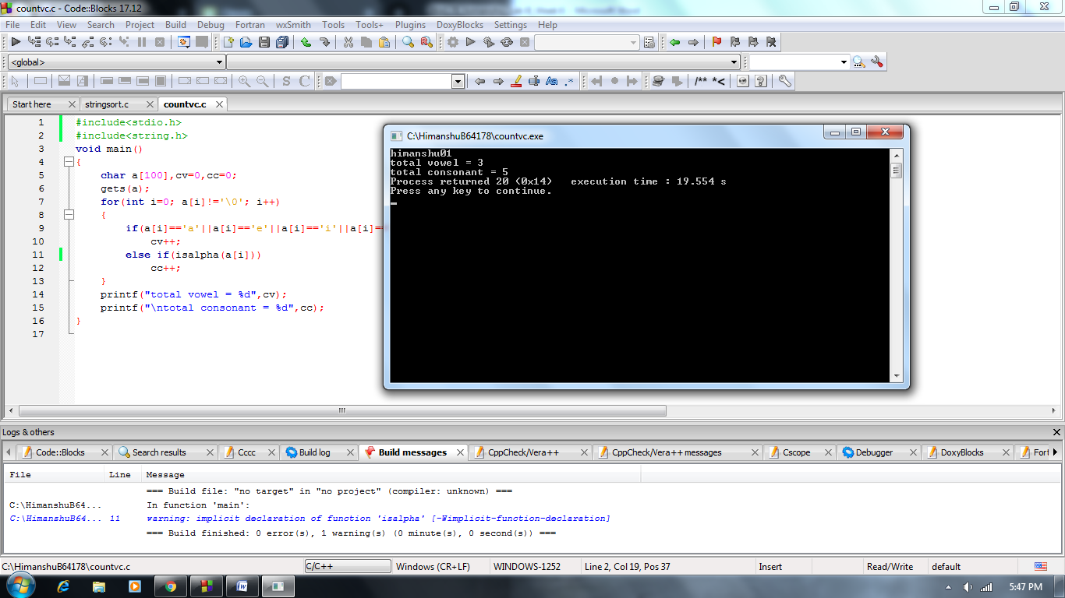

***5.*** *Write C program which will perform the following task on String.*

***a.*** *Comparison between two strings.*

***Solution:***

#include<stdio.h>

#include<string.h>

void main()

{

char a[100],b[100];

gets(a);

gets(b);

if(strcmp(a,b)==0)

printf("Both string are same");

else

printf("strings are different");

}

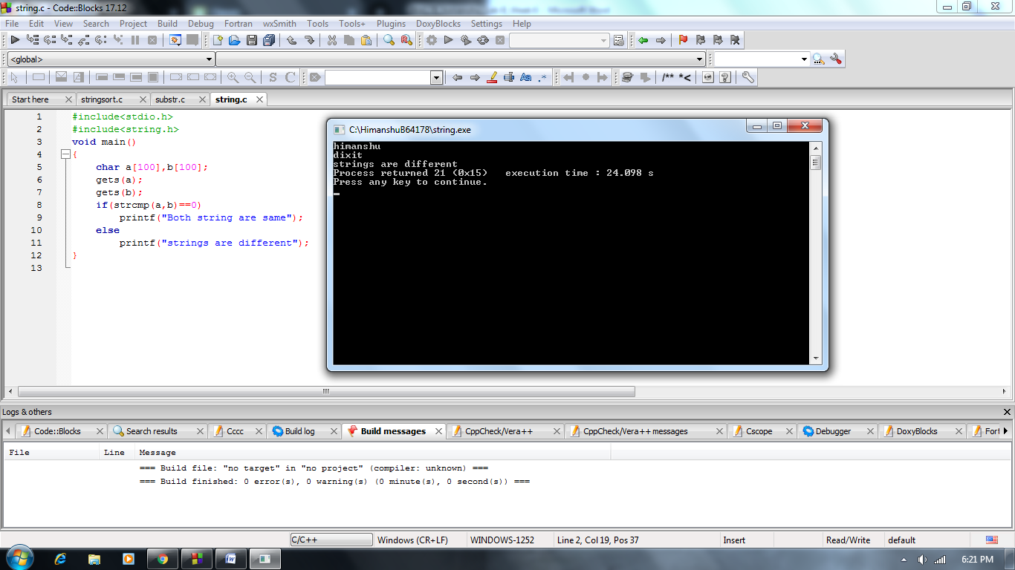

***b.*** *Finding substring.*

***Solution:***

#include<stdio.h>

#include<string.h>

#include<stdlib.h>

void main()

{

char a[100],b[100];

gets(a);

printf("\n");

gets(b);

for(int i=0;i<strlen(a);i++)

{

if(b[0]==a[i])

{

for(int k=1;k<strlen(b);)

{

if(b[k]!=a[i+1])

{

printf("\nsubstring not found");

exit (0);

}

k++;

i++;

}

printf("\nsubstring found");

}

}

}

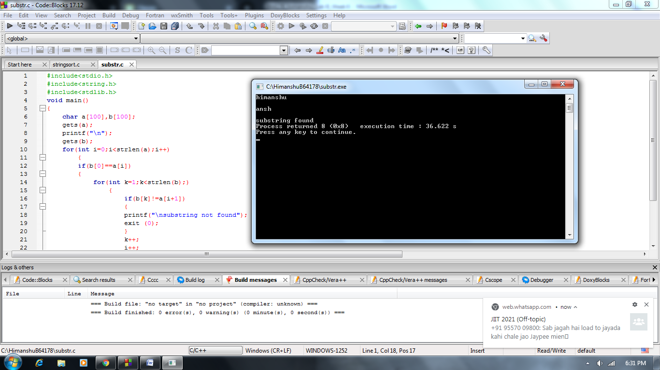

***c.*** *Sorting names of students.*

***Solution:***

#include<stdio.h>

#include<string.h>

void main()

{

char a[100][100],b[100];

int n;

printf("number of names : ");

scanf("%d",&n);

printf("enter students name : \n");

for(int i=0;i<n;i++)

scanf("%s",a[i]);

for(int i=0;i<n;i++)

{

for(int j=i+1;j<n;j++)

{

if(strcmp(a[i],a[j])>0)

{

strcpy(b,a[i]);

strcpy(a[i],a[j]);

strcpy(a[j],b);

}

}

}

printf("\nafter sorting : \n");

for(int i=0;i<n;i++)

printf("%s\n",a[i]);

}

